Grade 7 Accelerated · Unit 4 · Lesson 5  Evaluating Expressions with Radicals  Independent Set 4.05 | Name______________________  Date______________________  Period____________________

Six questions, on your own, in silence. Show the step that does the work.
1. 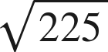

2. 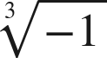

3. 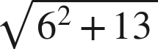

4. 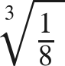

5. 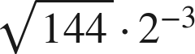

6. 